* Bookbag/backback

**Belair K-8 Kindergarten Supply List**

* Headphones (no earbuds or Bluetooth)
* 24 count crayons (2 packs)
* Fine tip dry erase markers (black)
* 1 box of #2 Pencils
* Pencil box / Supply container
* 1 pair blunt tip/ safety scissors
* 2 packs 3x5 index cards
* 1 box of gallon sized Ziploc bags (boys)
* 1 box of quart sized Ziploc bags (girls)
* 2 folders with pockets only
* Glue sticks
* 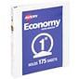1 pack of erasers
* Tissue
* Markers
* 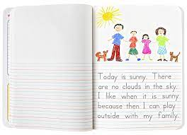2 clear view binders - 1”
* Primary writing tablet or notebook with lines that look

like this.

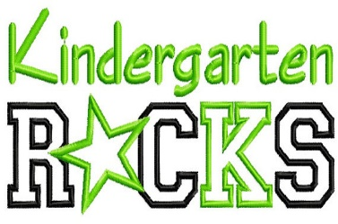Wish list – (not required)

* 1 pack of white copy/printer paper
* Paper Towels
* Anti-bacterial wipes